Lab 0

Setting up your device and Arduino IDE

Please be sure to first watch the video linked below. Use these instructions if you are using Windows OS.

[Click Here](https://www.youtube.com/watch?v=4hdZzTUxjQQ) to watch the video tutorial!

* Download the Arduino IDE
  + <https://www.arduino.cc/en/software>
* Set up Arduino IDE to recognize kit
  + Copy link below
  + <https://raw.githubusercontent.com/espressif/arduino-esp32/gh-pages/package_esp32_index.json>
  + Launch Arduino IDE
  + Navigate to “Preferences” or Ctrl+Q (Windows)
    - Select circled button

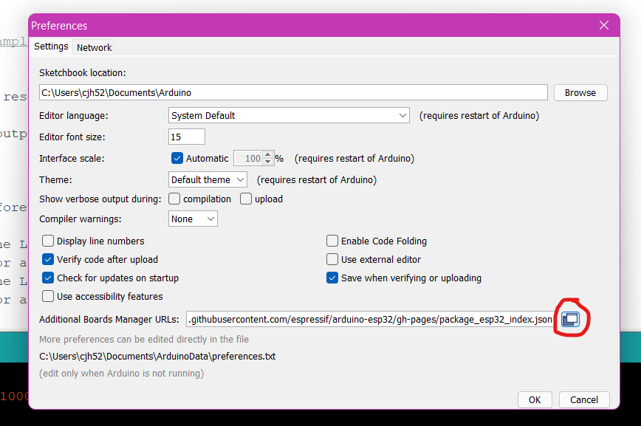

* + Paste link from above and confirm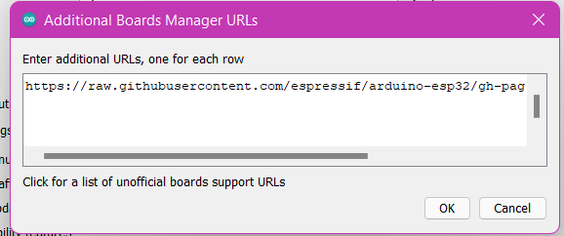
  + Navigate to “Tools” \ Boards \ Board Manager
    - *Yours may look slightly different
  + 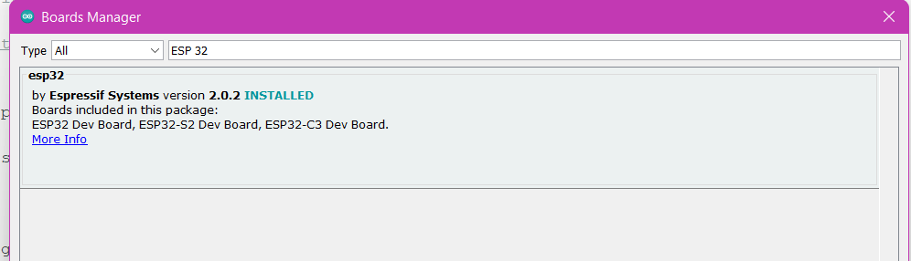Search “ESP 32” and select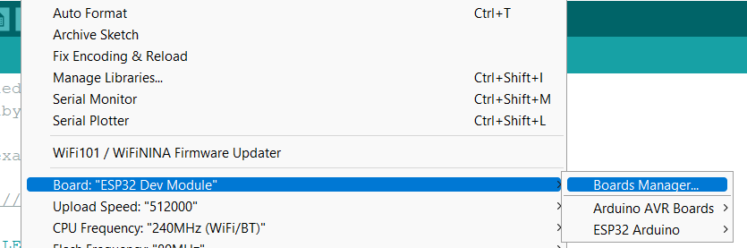
  + Navigate to Tools \ Boards \ ESP32 Arduino\ *select* ESP32 Dev Module
  + Adjust upload speed via Tools\Upload Speed
* You should be all set to start writing to your kit! Give it a test by uploading the “Blink.ino” file!
  + Play around with some of the values to adjust speed, and try to change which led blinks!